A Critical Review on Synthesis of CuO Nanostructures by Different Chemical Methods and Their Size Predication Through Adaptive Neuro-Fuzzy Inference System
Jinitha C G ª, D. Renuga ^{b}, S. Sonia ^{b} and S. Virgin Jeba ^{c}
ª Research Scholar (Reg. No. 19213042132016), Department of Physics, Holy Cross College, Nagercoil-4, Affiliated to Manonmaniam Sundaranar University, Abishekapatti, Tirunelveli-627012, India.
^{b} Department of Physics, Holy Cross College, Nagercoil-4, India.
^{c} Research Scholar, Department of Physics, Holy Cross College, Nagercoil, Affiliated to
Manonmaniam Sundaranar University, Abishekapatti, Tirunelveli-627012, India

ABSTRACT
Cupric oxide (CuO) nanowires and nanoflowers have been a great interest in ample of fields including energy conversion devices and optoelectronic devices. Although the required advanced qualities have been established, these materials are now unable to be made in large-scale quantities in order to overcome the technology gap and make them more widely available. The search for the most efficient synthesis procedure that produces not only huge quantities but also high quality and advanced material qualities continues in this regard. This study provides a comprehensive overview of copper oxide nanowire (NW) and nanoflower (NF) synthesis, including all methods and pathways used by different researchers. These strategies are examined, assessed, and compared in depth. Wet-chemical methods based on pure solution growth, electrochemical and hydrothermal pathways, as well as thermal and plasma oxidation methods, are all used to generate copper oxide nanostructures. Hydrothermal and solvothermal technologies are important in size and shape controlled synthesis. These technologies create high-quality material with improved qualities in addition to vast amounts of NWs. Also, the size of the synthesized CuO nanostructures was predicted by neuro-fuzzy inference system.
Keywords: CuO; Nanoflowers; Nanowires; Hydrothermal Method.

1. INTRODUCTION
Now-a-days semiconductors are commonly used in our day-to-day life and also used in many industrial applications. In recent years, development in scientific technology has improved a lot and the advancement in nanoscience is an incredible one. Copper has two natural oxides: cuprous oxide and cupric oxide. Both are the semi-conductors with the band gaps of 2.0 eV and 1.2 eV respectively [1]. Their band gaps make them as good candidates for photovoltaic devices, catalysts, sensors and optoelectronic devices. In this review we are going to discuss about the synthesis of copper oxide nanoparticles with different morphologies like nanoflower, nanorod, nanosphere and nanowire by using various synthesis methodologies such as hydrothermal, electrochemical, one-pot method, mechano-chemical method and so on for various applications [2] (Fig.1).
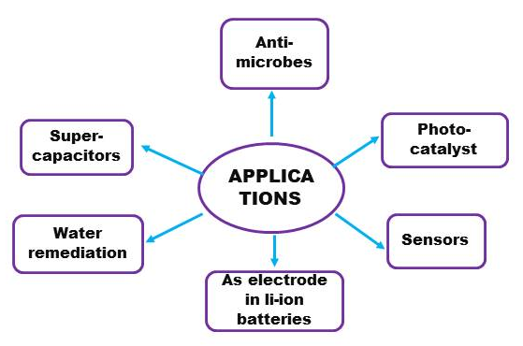
Fig.1. Flow Chart for Applications of CuO Nanostructures

2. SYNTHESIS OF CuO NANOSTRUCTURES
Hydrothermal synthesis was the predominantly used methodology for synthesis of copper nanoparticles. Satish P Mardikar et al, S. Sonia et al.,Weina Xu et al., Zhijie Li et al., Aixia Gu et al.,Yulan Wang et al and many other reported syntheses of nanoflower copper nanoparticle using hydrothermal method under various temperature using different precursors [3]–[8]. The most commonly used solvent in this method is ethanol and water in its various forms. The autoclave used for the synthesis of copper oxide nanoparticles is Teflon-lined stainless steel autoclave. In this hydrothermal method the precursor is dissolved in the suitable solvent such as ethanol, deionized water, or double distilled water. And the solution is stirred continuously and then it is treated in the autoclave under hydrothermal conditions. Then it is cooled to the room temperature and again it is washed and dried. It I thermally treated and centrifuged under ambient conditions. Finally, the sample is prepared. Then the sample is characterized to found the morphology of the sample material. Yuan Cai et al., and Anuj A Vargeese et al reported synthesis of copper oxide nanorod using hydrothermal method at 35°C for 1 hr, 160°C for 1 hr, 150°C for 3 hrs, 600°C for 3 hrs and 130°C for 1 hrs with cupric acetate and copper acetate as the precursors which are dissolved in deionized water [9], [10]. Then the sample material is characterized using various methods such as XRD, FTIR, HR-TEM, SEM etc. Thus, the produced morphologies are with different shapes and size. The material produced using this method is mostly used in the application of sensors (Fig.2.).
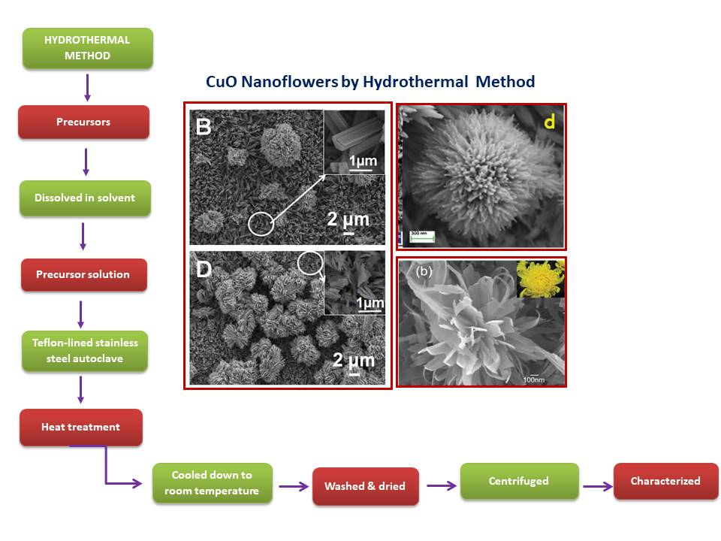
Fig.2. Schematic Illustration of Hydrothermal Synthesis of CuO Nanoflowers
Table.1. Summary on the effect of starting materials, solvents, and surfactants on morphology of CuO nanostructures.
S. No. | Materials | Method | Reaction Condition | Precursors/ Surfactant Used | Solvent | Characterization Techniques | Morphology & size Obtained | Application | Reference
1 | CuO | Low- temperature synthesis method | 100°C -7hrs | Cupric nitrate | Distilled  Water  100ml | FESEM, XRD, FTIR,EDS | Nano flower 20-90nm | sorbent  material for waste water treatment | [11]
2 | CuO | Solution combination | 300°C | Cupric nitrate  glycine as fuel | Deionized  Water | FESEM, HRTEM, XRD | Nano flower 50nm | Photo-catalyst | [12]
3 | CuO | hydrothermal Synthesis | 120°C-12hrs 60°C-8hrs | Copper acetate monohydrate,  Copper nitrate trihydrate,  Sodium hydroxide | Distilled water (75ml) | XRD, EDAX, FESEM,TEM | Nano flower | Photo-catalyst | [3]
4 | Zn-CuO | hydrothermal method | 160°C-12hrs | Copper nitrate, zinc nitrate | Distilled water  (40ml) | XRD, FESEM, EDX,UV-Visible spectrometer | Nano flower | Photo-degradation material in textile dyes | [4]
5 | Pd-CuO | Low- temperature synthesis method | 80°C 8000 rpm-10mins | Copper nitrate trihydrate, dihydrogen tetrachloro-palladate | Deionized water, copper nitrate solution  1000ml | XRD,SEM, TEM,EDX | Nano flower 400nm | gas sensors | [13]
6 | CuO | Chemical Oxidation | 60°C-6hrs | Sodium hydroxide, copper powder | Distilled water  (20ml) | XRD,TEM | Nano flower 200-400nm | (H₂O₂)  Hydrogen per oxide sensors | [14]
7 | CuO | Low- temperature method chemical bath method | 90°C 4-5hrs | Copper nitrate, hexa-methylene | Deionized water | XRD,SEM, FESEM, HRTEM | Nano flower 200nm | fabricate pH sensor | [15]
8 | CuO | Hydrothermal method | 373 K for 6hrs,12hrs,24hrs 333k for 3hrs | (CH₃COO)₂ Cu. 2H₂0 | Deionized water  (20ml) | FESEM,XRD ,EDS | Nano flower | Super capacitors | [5]
9 | CuO | facile hydrothermal method | 90°C-3hrs | Copper nitrate | Double distilled water  100ml | XRD,FTIR,SEM,EDX | Nano flower 200-500nm | Non-enzymatic glucose sensor | [16]
10 | CuO | Electrochemical Method | 180°C- 12hrs | Acetyl-thiocholine, Acetyl-cholinesterase | Ethanolacetonedeionized water 100ml | FESEM, EIS | Nano flower 200nm | biosensor | [17]
11 | CuO | Hydrothermal synthesis | 180°C-12hrs 80°C-2hrs | Cu (CH₃COO)₂. H₂O | Water (50ml) | XRD, XPS, HRTEM,  UV-Vis spectroscopic analysis | Nano flower 60nm | H2S sensing | [6]
12 | CuO | Biosynthesis |  | Ocimum Sanctum as stabilizing agent eugenol as capping agent |  | XPS, XRD, FESEM, TEM | Nano flower 50nm | Photo-catalytic against methylene blue | [18]
13 | CuO | Hydrothermal method | 100°C-6hrs | Cu(NO₃)₂. H₂O,NH₃.H₂O | Distilled water (10ml) | XRD,FESEM | Nano flower 3-5nm | H2O2 sensor | [7]
14 | CuO | facile one pot synthesis | 75°C-2mins 10000rpm -2mins | Cu₂(NO₃). (OH)₃  as precursor | Ultrapure water, ethanol (30ml) | XRD, FESEM,TEM, HRTEM,SAED,XPS | Nano flower 100-300nm | glucose sensor | [19]
15 | CuO | Submerged Photosynthesis of crystallites | At low temperature |  | Ultrapure water (4ml) | FESEM, EDS, XRD, TEM | Nano flower 100nm | Anti-microbe | [20]
16 | CuO | facile hydrothermal method | 120°C-2hrs 60°C-4hrs | CuSO₄.5H₂O, NaOH | Double distilled water (40ml) | XRD, SEM, TEM,HRTEM | Nano flower 200-300nm | Oxidative degradation of organic pollutants in waste water | [21]
17 | CuO | immobilized resin method or ion-exchange method | 80°C-5hrs | 5ml 0.1M NaOH 2ml 0.1M CTAB | Double distilled water (7ml) | FTIR, XRD, XPS, TEM,HRTEM, FESEM | Nano flower 700nm-800nm | catalyst | [22]
18 | CuO | One- Pot synthesis | 35°C-40°C 180°C-40mins | Cu(OAC)₂. H₂O | Ethanol water 140ml | XRD,TEM, XPS, UV-Vis Spectroscopy, Raman Spectroscopy | Nano flower 50-100nm | Photo-catalyst | [23]
19 | CuO | Chemical bath deposition | 343K | aqueous ammonia  as complexing  agent, copper nitrate | Double distilled water | XRD,SEM,XPS, TEM,HR-TEM,BET | Nano flower 20nm | Super-capacitor | [24]
20 | CuO | One-Pot water bath method | 70°C-15mins 60°C-12hrs | Cu(CH₃COO)₂  NaOH & aqueous/ ethanol | Distilled water, ethanol (100ml) | XRD,SEM,TEM,SAED | Nano flower 500-1400nm | Super-capacitor | [25]
21 | CuO | Chemical vapor deposition |  | Cu based MOF | KOH solution | SEM,TEM,XPS | Nano flower 100-500nm | water oxidation | [26]
22 | CuO | Hydrothermal method | 72hrs at room temperature | NaOH in H₂O;Cu(NO₃)₂  in ethanol | Deionized water (20ml) | SEM | Nano flower 250 nm | Electro-chemical immuno sensor | [8]
23 | CuO | Simple  solution route | At room temperature | Cu plate, KOH | Deionized water | SEM,TEM,XRD | Nano flower 200 nm | Nano-electronic device | [27]
24 | CuO | Chemical-assisted hydrothermal process | 170°C -24hrs 100°C-6hrs 600°C-2hrs | Cupric nitrate, ammonium bicarbonate | Deionized water (25mml) | XRD,XPS, FESEM | Nano flower 500-700nm | sensors | [28]
25 | CuO | Interfacial assembly technique | 95°C-120mins | Copper(II) sulphate pentahydrate, sodium tartrate | Water (1 liter) | XRD,XPS,SEM, TEM,HR-TEM | Nano flower 200-250nm |  | [29]
26 | CuO | Low temperature sonochemical method | 160°C-12hrs 80°C-6hrs | Copper acetate | Distilled water (100ml) | XRD,FTIR,FESEM | Nano flower 50-400nm |  | [30]
27 | CuO | Hydrothermal method | 180°C-16hrs 3000rpm-15mins | CuCl₂.2H₂O NaCO₃ | Deionized water (40ml) | TEM,HR-TEM,XRD | Nano flower 100nm | sensors | [31]
28 | CuO | Double-hydroxide treatment | 200°C-24hrs | Cupric nitrate | Deionized water | XRD,TEM, SEM,HR-TEM | Nano flower 300-600nm |  | [32]
29 | CuO | One-step room temperature synthesis | 60°C-6hrs | NaOH, (NH₄)₂S₂O₈ | Deionized water, ethanol (18ml) | SEM,TEM, HR-TEM,XRD | Nano flower 400-600nm | Photo-catalyst | [33]
30 | CuO | Hydrothermal method | 80°C-18hrs | Suberic acid, ammonia solution, copper chloride, ammonium chloride, NaOH | Deionized water, ethanol (200ml) | FTIR,XRD,SEM | Nano flower 100-200nm | sensors | [34]
31 | CuO | Mechano-chemical method | 400°C-2hrs | Cu(CH₃COO)₂.H₂O, (NH₄)₂ C₂O₄.H₂O 1:1 |  | SEM,TEM,XRD,  FTIR | Nano rod 75nm | super-capacitors | [35]
32 | CuO | Solvothermal method | 350°C-2hrs | Copper chloride, Sodium hydroxide | Deionized water (100ml) | XRD,FTIR,TEM | Nano rod 15nm |  | [36]
33 | CuO | Mechano-chemical method | 400°C-2hrs | Cu(CH₃COO)₂.H₂O, (NH₄)₂ C₂O₄.H₂O 2:3 |  | SEM,TEM, XRD,FTIR | Nano wire 61nm | super-capacitors | [37]
34 | CuO | Seed mediated hydrothermal method | 250°C-2.5hrs 70-85°C for 2-5hrs | CuO nanoseed copper acetate monohydrate | Deionized water (25ml) | FESEM,XRD,EDX | Nano rod 56-73nm |  | [38]
35 | CuO | Solid-state growth | 650°C-2hrs 800°C-2hrs | CuC₂O₄ | Distilled water, ethanol (10ml) | XRD,TEM | Nano rod 15-20nm |  | [9]
36 | CuO | Hydrothermal synthesis | 35°C-1hr 160°C-180°C-4hrs 600°C-3hrs | Cupric acetate | Deionized water (200ml) | XRD,FTIR,FESEM | Nano rod 30-50nm |  | [39]
37 | CuO | Wet-chemical reduction method | 700rpm at 80°C | Copper acetate | Deionized water (100ml) | XRD,TEM,UV-Vis spectroscopy ,FTIR | Nano rod 100nm | anti-bacterial activity | [40]
38 | CuO | Sono-assisted reverse precipitation method | 25°C-15mins | Graphene oxide, CuSO₄.5H₂O | Ultrapure water (20ml) | SEM,TEM,XRD,FTIR | Nano rod 40nm | synergistic activator | [41]
39 | CuO | Biosynthesis | 600rpm-1 hr at 80°C 200°C-1hr | Cynodon Dactylon & Cyperus Rotundus grass extract, copper nitrate trihydrate | Double distilled water | XRD,SEM,EDAX, FTIR | Nano rod 50-100nm Nano prism 300-500nm Nano particle 50-100nm | anti-bacterial activity | [42]
40 | CuO | Solvo-thermal method | 180°C-3hrs 120°C-12hrs | C₆H₁₂O₆ | Purified water (50ml) | XRD,FESEM, HR-TEM,XPS | Nano rod 30-50nm | lithium storage | [43]
41 | CuO | Green synthesis | 100°C-7 to 8 hrs 90°C-7hrs | Ruellia tuberosa | Deionized water (50ml) | FTIR,FESEM, EDAX,TEM | Nano particle 20-100nm | anti-bacterial activity | [44]
42 | CuO | Electrochemical Method | 120°C-1hr 60°C-4 to 6hrs | CuSO₄.5H₂O, salicylic acid | DD water, ethanol (40ml) | XRD,FESEM, TEM,HR-TEM,FTIR | Nano rod 20-30nm nanowire 20nm | oxidative degradation | [45]
43 | CuO | Microwave heating | 640W, 90°C-10mins to 2hrs | CuO nanoseed, copper nitrate trihydrate, hexa-methylene tetramine | Deionized water | FESEM,HR-TEM | Nano rod 50nm |  | [10]
44 | CuO | Hydrothermal method | 130°C-1hr | Copper acetate, urea | Deionized water (20ml) | XRD,HR-TEM,TEM | Nano rod 5nm |  | [46]
45 | CuO | Hydrothermal method | 150°C-12hrs 60°C-12hrs | Cu (CH₃COO)₂ .H₂O | Deionized water (40ml) | XRD,HR-TEM,TEM | Nano wires 15nm | charge storage | [47]
46 | CuO | Template route through thermal transformation | 150-450°C-1hr 80°C-20mins | Cu(OH)₂ | Deionized water (50ml) | SEM,XRD,XPS | nanowires 70-120nm | Photo-electro-chemical hydrogen generation | [48]
47 | CuO | Interfacial precipitation method | 60°C-8hrs 350°C-3hrs | Copper acetate, dimethyl oxalate | Ether, ethanol, water (100ml) | XRD,SEM,TEM | nanowires 100nm |  | [49]
48 | CuO | Thermal annealing process | 500°C-2hrs | Copper sulfate pentahydrate | Ethanol (30ml) | FESEM,XRD | Nano sphere 95nm | ultra-violet photo detector | [50]
49 | CuO | Sonication method | 6hrs 70°C-2hrs 400°C-1hr | Copper acetate, copper chloride, copper nitrate | Double distilled water | XRD,SEM,FTIR | Nano sphere 120-160nm Nano flower 50nm | Photo-degradation | [51]
50 | CuO | Microwave-assisted process | 500W-10mins 500°C in Ar atmosphere 200°C-2hrs | Graphene oxide, Cu(AC)_{2.}H₂O | Anhydrous ethanol (80ml) | XRD,SEM, TEM,HR-TEM | Nano sphere 120-200nm | anode for Li-ion battery | [52]

Hafsa Siddiqui et al, S. Suresh et al and some others have reported the synthesis of copper oxide nanoparticle by bio-synthesis method (Fig.3) which is non-toxic and ecofriendly [18], [41]. In this method the leaves, extract or roots of the plants are used. The collected fresh material is washed and dried under shadow at room temperature. Then it is grounded and treated with a suitable precursor and treated for the synthesis of nanoparticle. The prepared sample is characterized to found the morphology of the prepared sample. The copper oxide nanoparticle prepared under this method is used for medical applications, for removal of pollutants and as a photo-catalyst.
Shaodong Sun et al, Mrinmoyee Basu et al, Shinde et al, Sonia et al have reported the synthesis of copper oxide nanoflower with different size varies from 50 nm-800 nm by various methods such as one-pot synthesis, ion-exchange method, chemical bath deposition, sonochemical method respectively by using different precursors based on copper and suitable solvents under various thermal conditions [4], [19], [22], [24]. The application depends on each synthesis method. The application mentioned for the above methods are sensors, catalyst, super-capacitor etc.
Copper oxide nanorods are mostly used as an electrode for lithium ion batteries. Ameri et al, Wang Jisen et al, Asamoah et al, Wang et al and some others have reported the synthesis of copper oxide nanorods for various applications by various method such as mechano-chemical method, solid-state growth, wet-chemical reduction, precipitation etc.,[35], [38]–[40].
Sumeet Kumar et al, Yu-Kuei Hsu et al, Ni Liang et al reported about the synthesis of copper oxide nanowire by hydrothermal method, thermal transformation, and precipitation method respectively [46]–[48]. But in all these methods of synthesis the solvent used is deionized water but with different precursors under different thermal conditions. Hao Li et al and Ameri et al reported synthesis of copper oxide nanowire along with some other structures under varying thermal conditions [35], [44]. In Ameri et al’s report he reported that copper oxide nanowire is synthesized by mechano-chemical method under the same thermal condition as like as for the other structures but the ratio of the precursors used for the synthesis differs for each of the structure [35]. For nanowire synthesis the ratio is 2:3 of Cu(CH₃COO)₂.H₂O and (NH₄)₂C₂O₄.H₂O is used. The copper oxide nanowire synthesized is of 56-73nm in diameter and 2 micrometers in length. In Hao Li et al’s report he suggested that the synthesis of copper oxide nanowire is synthesized by electro-chemical method with varying thermal condition for various nano structures of copper oxide [44]. The thermal condition for the synthesis of nanowire is 60°C-6 hrs with copper sulphate pentahydrate and salicylic acid as precursors and the synthesized nanowire is of 20 nm in diameter.
S. Suresh et al reported the synthesis of copper oxide nanostructures by bio-synthesis method using cynodon dactlon, cyperus rotundus grass extract and copper nitrate trihydrate as a precursor [41]. He studied that by varying the thermal conditions, we can obtain different nanostructures such as nanorod, nanoprism, and nanoparticle with various diameter. The samples are characterized by XRD, SEM, FTIR and EDAX. The main application of copper oxide nanostructure produced by this method is it acts as an anti-bacterial source.
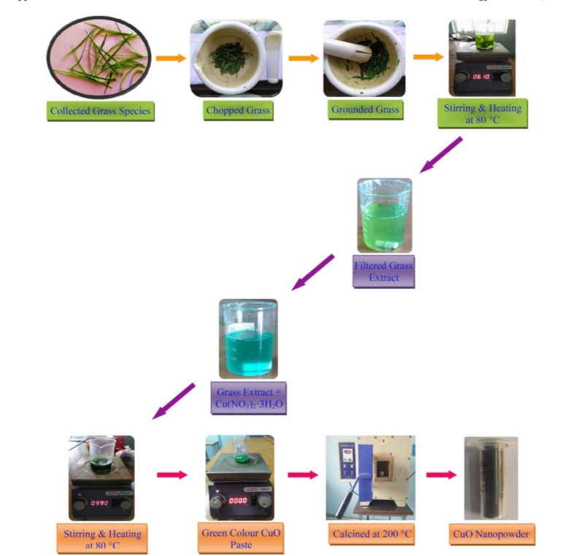
Fig. 3. Schematic illustration of Bio-Synthesis
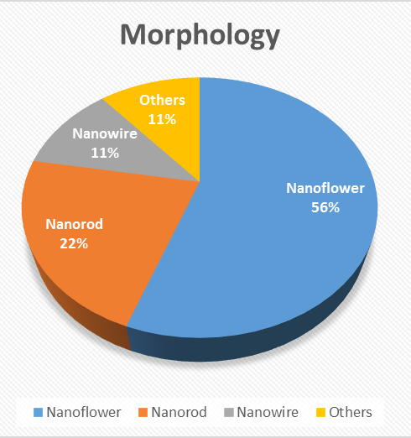
Fig. 4. Histogram for the available synthesized CuO nanostructures

3. EFFECT OF STARTING MATERIALS

3.1. Solvent
Solvent is an essential component of wet chemical techniques since it has a significant impact on the final result. Because of the importance of the solvent, it is sometimes used to refer to a specific wet chemical method, such as alcohol-thermal synthesis or the DMSO (dimethyl sulfoxide) route . The following are two major criteria for the solvents used to manufacture CuO nanostructures: They dissolve copper and alkali hydroxide compounds and may be washed away or destroyed quickly during the washing and drying process, leaving no harmful contaminants or residues in the final nanoproduct. Many secondary parameters, including as viscosity, surface tension, volatility, reactivity, toxicity, and cost, should be carefully considered during the synthesis process. Polar solvents are typically employed to synthesise CuO nanostructures in order to dissolve copper salts and alkali hydroxide, which are ionic compounds. Water is unquestionably the most cost-effective, safe, and ecofriendly solvent. In fact, most papers use water as a solvent to make CuO nanostructures; however, there are only a few reports that use water alone, without any additions or surfactants (see Table 1). Large (many hundreds of nanometers) and non-uniform size and shape particles or complex structures, such as 3D flower-like structures, are typically produced when nanostructures are formed in water without any additions. These findings suggest that water has various drawbacks that lead scientists to choose other organic solvents such as alcohols with varying carbon chain lengths or functional groups (OH). The main downside of utilizing water as a solvent is that it encourages coarsening during the formation of nanostructures formed in the liquid phase. Capillary effects control coarsening, which entails the formation of larger crystals at the expense of smaller crystals. Because a particle's chemical potential increases as particle size decreases, the equilibrium solute concentration for small particles is substantially higher than for large particles, implying that larger particles are more energetically favourable than smaller particles. The ensuing concentration gradients cause solute to be transported from small to larger particles [53].

3.2. Salt and Alkali Metal Solution
In theory, any soluble copper salt might be used as a precursor to make CuO nanostructures without any difference, and there doesn't appear to be any research on the effect of copper salt precursor. CuO nanomaterials were made using a variety of copper salts, including chloride, nitrate, sulphate, and acetate. The particle size and uniformity of copper nanoparticles made from copper acetate appear to be better than those made from inorganic copper salts. A plausible explanation is that carboxylate groups remain adsorbed on the surface of copper oxide nanoparticles and act as a surfactant, preventing nanoparticles from growing and aggregating. The base agent, which provides hydroxyl ion to react with copper salt and precipitate Cu(OH)₂, is another important precursor for the production of CuO nanoparticles. Sodium hydroxide and potassium hydroxide are the most commonly utilised precursors. NaOH appears to be chosen only because it is less expensive than KOH, despite the fact that both compounds have nearly identical characteristics. Although NH₄OH might be used, its high volatility limits its use during the synthesis process, and as a result, NH₄OH appears in only a few publications of CuO nanoparticle preparation. Because of the strong polar character of ammonia, according to Sun et al., employing it may improve product agglomeration. Although the mole ratio of copper ion to OH group should be 1: 2, many Cu salts rapidly hydrolyze in water, resulting in high solution acidity (pH < 2), despite the fact that pH can play a crucial part in the dynamic process during the reaction. As a result, the Cu²⁺/OH ratio in the precursor solution could be tweaked from report to report to get the appropriate morphology and size of nanoproduct. By employing low concentrations of reactants, a slower reaction rate can be accomplished, resulting in smaller products with a narrow size distribution. However, if the Cu salt concentration is too low, the amount of CuO product produced is minimal. Concentrations that are too high cause the product to agglomerate, therefore the concentration of the precursor solution should be carefully determined to strike a balance between quantity and quality, which refers to the nanoproduct's small size and good separation. The use of low concentration solutions may be a barrier to mass manufacturing of nanoproducts due to solvent waste, although recycling the wasted solvent may be a solution to this problem [53].

4. SIZE PREDICTION USING NEURO-FUZZY DESIGNER
Simulation is required for parameter optimization and to keep the reaction at a low cost. Due to their acceptable accuracy inside the simulation, Artificial Neural Network (ANN) and Fuzzy Logic (FL) are the most prevalent soft computing technologies. We used an Adaptive Neuro-Fuzzy Inference System (ANFIS) to optimize the conditions for nanosphere creation in this work [54]. The system is designed as INPUT, OUTPUT and CPU [55].
The outputs were standardized in order to reduce fluctuation in the data range. Followed by calculation of grey relation coefficient using the relation,
$Δ_{min}$= smallest value of $Δ_{0i}\left(k\right)$
$Δ_{max}$= largest value of $Δ_{0i}\left(k\right)$
$\left(x_{0}*\left(k\right)- x_{i}*\left(k\right)\right)= Δ_{0i}\left(k\right)$. x₀*(k) = ideal sequence

The grey relational coefficient is given by the following formulae,
$$x_{i}=\left(x_{i}\left(1\right),x_{i}\left(2\right),….,x_{i}\left(n\right)\right), x_{i}ϵX, i=1, 2,…, m$$
xi be the compared series and x0 be the reference series
$$x_{0}=\left(x_{0}\left(1\right),x_{0}\left(2\right),….,x_{0}\left(n\right)\right), x_{0} ϵX$$
The grey relational coefficient is given by,

$$γ(\left(x_{0}\left(k\right), x_{i}\left(k\right)\right)= \frac{Δ_{min}+ ζΔ_{max}}{Δ_{0i}\left(k\right)+ ζΔ_{max}}$$

The grey relational grade is obtained from the following formula
$$γ\left(x_{0}, x_{i}\right)= \frac{1}{n}\sum_{k=1}^{n}{γ(ᵡ_{0}}\left(k\right),x_{i}(k))$$

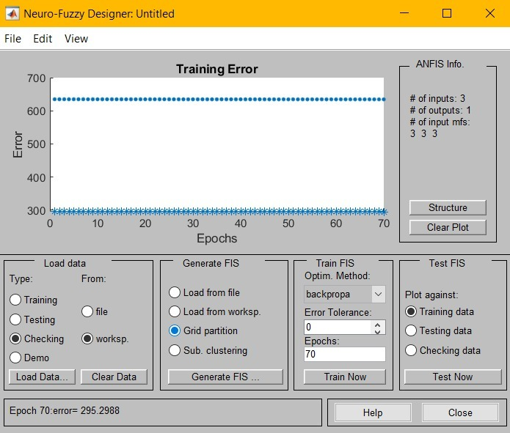
Fig. 5. Training Error
From the above input parameters from maximum to minimum values, the output data does not correlated, since the different reaction conditions offers the same size of nanoflowers. While changing the reaction parameters the output results value does not changes. Therefore, the software shows training error. The outputs results indicate that the size and morphology are changing may be due to the environment and quality of precursors.

5. CONCLUSION
In this study, we have successfully discussed the synthesis of CuO nanostructures by various chemical methods using different precursors. Also, we have predicted the size of the synthesized CuO nanostructures by neuro-fuzzy inference system. Even though hydrothermal method is an efficient size and morphology controlling process, it will depend on the reaction environment. In some cases, the precursor determines the shape of the nanostructures. Similarly for particular application some specific shaped nanostructures are used. For example, in solar cell arrays, the copper oxide nano-rod is used. The overall results elucidate that the CuO nanostructures could be useful in water remediation, charge storage, bacterial growth inhibition, sensors and as an electrode in Li-ion batteries, etc.

References
[1] J. Demel, A. Zhigunov, I. Jirka, M. Klementová, and K. Lang, “Facile synthesis of CuO nanosheets via the controlled delamination of layered copper hydroxide acetate,” J. Colloid Interface Sci., vol. 452, pp. 174–179, Aug. 2015, doi: 10.1016/j.jcis.2015.04.023.
[2] J. N. Tiwari, R. N. Tiwari, and K. S. Kim, “Zero-dimensional, one-dimensional, two-dimensional and three-dimensional nanostructured materials for advanced electrochemical energy devices,” Prog. Mater. Sci., vol. 57, no. 4, pp. 724–803, May 2012, doi: 10.1016/j.pmatsci.2011.08.003.
[3] S. P. Mardikar, S. Kulkarni, and P. V. Adhyapak, “Sunlight driven highly efficient degradation of methylene blue by CuO-ZnO nanoflowers,” J. Environ. Chem. Eng., vol. 8, no. 2, p. 102788, Apr. 2020, doi: 10.1016/j.jece.2018.11.033.
[4] S. Sonia, I. Jose Annsi, P. Suresh Kumar, D. Mangalaraj, C. Viswanathan, and N. Ponpandian, “Hydrothermal synthesis of novel Zn doped CuO nanoflowers as an efficient photodegradation material for textile dyes,” Mater. Lett., vol. 144, pp. 127–130, Apr. 2015, doi: 10.1016/j.matlet.2015.01.026.
[5] W. Xu, S. Dai, G. Liu, Y. Xi, C. Hu, and X. Wang, “CuO Nanoflowers growing on Carbon Fiber Fabric for Flexible High-Performance Supercapacitors,” Electrochimica Acta, vol. 203, pp. 1–8, Jun. 2016, doi: 10.1016/j.electacta.2016.03.170.
[6] Z. Li et al., “Hydrothermal synthesis of hierarchically flower-like CuO nanostructures with porous nanosheets for excellent H2S sensing,” J. Alloys Compd., vol. 725, pp. 1136–1143, Nov. 2017, doi: 10.1016/j.jallcom.2017.07.218.
[7] A. Gu, G. Wang, X. Zhang, and B. Fang, “Synthesis of CuO nanoflower and its application as a H2O2 sensor,” Bull. Mater. Sci., vol. 33, no. 1, pp. 17–20, Feb. 2010, doi: 10.1007/s12034-010-0002-3.
[8] Y. Wang et al., “Layer-by-layer self-assembly of 2D graphene nanosheets, 3D copper oxide nanoflowers and 0D gold nanoparticles for ultrasensitive electrochemical detection of alpha fetoprotein,” RSC Adv., vol. 5, no. 70, pp. 56583–56589, Jun. 2015, doi: 10.1039/C5RA07547E.
[9] Y. Cai et al., “Hydrothermal-ultrasonic synthesis of CuO nanorods and CuWO4 nanoparticles for catalytic reduction, photocatalysis activity, and antibacterial properties,” Mater. Chem. Phys., vol. 258, p. 123919, Jan. 2021, doi: 10.1016/j.matchemphys.2020.123919.
[10] A. A. Vargeese and K. Muralidharan, “Kinetics and mechanism of hydrothermally prepared copper oxide nanorod catalyzed decomposition of ammonium nitrate,” Appl. Catal. Gen., vol. 447–448, pp. 171–177, Dec. 2012, doi: 10.1016/j.apcata.2012.09.027.
[11] G. Bhanjana, N. Dilbaghi, K.-H. Kim, and S. Kumar, “Low temperature synthesis of copper oxide nanoflowers for lead removal using sonochemical route,” J. Mol. Liq., vol. 244, pp. 506–511, Oct. 2017, doi: 10.1016/j.molliq.2017.09.034.
[12] M. Umadevi and A. Jegatha Christy, “Synthesis, characterization and photocatalytic activity of CuO nanoflowers,” Spectrochim. Acta. A. Mol. Biomol. Spectrosc., vol. 109, pp. 133–137, May 2013, doi: 10.1016/j.saa.2013.02.028.
[13] X. Hu, Z. Zhu, C. Chen, T. Wen, X. Zhao, and L. Xie, “Highly sensitive H2S gas sensors based on Pd-doped CuO nanoflowers with low operating temperature,” Sens. Actuators B Chem., vol. 253, pp. 809–817, Dec. 2017, doi: 10.1016/j.snb.2017.06.183.
[14] R. Yuan, H. Li, X. Yin, L. Zhang, and J. Lu, “Stable controlled growth of 3D CuO/Cu nanoflowers by surfactant-free method for non-enzymatic hydrogen peroxide detection,” J. Mater. Sci. Technol., vol. 34, no. 9, pp. 1692–1698, Sep. 2018, doi: 10.1016/j.jmst.2017.11.030.
[15] S. Zaman, M. H. Asif, A. Zainelabdin, G. Amin, O. Nur, and M. Willander, “CuO nanoflowers as an electrochemical pH sensor and the effect of pH on the growth,” J. Electroanal. Chem., vol. 662, no. 2, pp. 421–425, Nov. 2011, doi: 10.1016/j.jelechem.2011.09.015.
[16] V. Vinoth, T. D. Shergilin, A. M. Asiri, J. J. Wu, and S. Anandan, “Facile synthesis of copper oxide microflowers for nonenzymatic glucose sensor applications,” Mater. Sci. Semicond. Process., vol. 82, pp. 31–38, Aug. 2018, doi: 10.1016/j.mssp.2018.03.032.
[17] J. Bao et al., “3D graphene/copper oxide nano-flowers based acetylcholinesterase biosensor for sensitive detection of organophosphate pesticides,” Sens. Actuators B Chem., vol. 279, pp. 95–101, Jan. 2019, doi: 10.1016/j.snb.2018.09.118.
[18] H. Siddiqui, M. S. Qureshi, and F. Z. Haque, “Biosynthesis of Flower-Shaped CuO Nanostructures and Their Photocatalytic and Antibacterial Activities,” Nano-Micro Lett., vol. 12, no. 1, p. 29, Jan. 2020, doi: 10.1007/s40820-019-0357-y.
[19] S. Sun, X. Zhang, Y. Sun, S. Yang, X. Song, and Z. Yang, “Hierarchical CuO nanoflowers: water-required synthesis and their application in a nonenzymatic glucose biosensor,” Phys. Chem. Chem. Phys., vol. 15, no. 26, pp. 10904–10913, Jun. 2013, doi: 10.1039/C3CP50922B.
[20] F. Nishino, M. Jeem, L. Zhang, K. Okamoto, S. Okabe, and S. Watanabe, “Formation of CuO nano-flowered surfaces via submerged photo-synthesis of crystallites and their antimicrobial activity,” Sci. Rep., vol. 7, no. 1, p. 1063, Apr. 2017, doi: 10.1038/s41598-017-01194-5.
[21] J. Liao, H. Li, X. Zhang, and D. Xiao, “Copper oxide nanoplatelets and nanoflowers: facile synthesis and catalytic activity in oxidative degradation of methylene blue,” Micro Nano Lett., vol. 9, no. 7, pp. 432–436, 2014, doi: 10.1049/mnl.2014.0199.
[22] M. Basu, A. K. Sinha, M. Pradhan, S. Sarkar, A. Pal, and T. Pal, “Monoclinic CuO nanoflowers on resin support: recyclable catalyst to obtain perylene compound,” Chem. Commun., vol. 46, no. 46, pp. 8785–8787, Nov. 2009, doi: 10.1039/C0CC03137B.
[23] S. Liu, J. Tian, L. Wang, Y. Luo, and X. Sun, “One-pot synthesis of CuO nanoflower-decorated reduced graphene oxide and its application to photocatalytic degradation of dyes,” Catal. Sci. Technol., vol. 2, no. 2, pp. 339–344, 2012, doi: 10.1039/C1CY00374G.
[24] S. K. Shinde, D. P. Dubal, G. S. Ghodake, and V. J. Fulari, “Hierarchical 3D-flower-like CuO nanostructure on copper foil for supercapacitors,” RSC Adv., vol. 5, no. 6, pp. 4443–4447, 2015, doi: 10.1039/C4RA11164H.
[25] B. Heng, C. Qing, D. Sun, B. Wang, H. Wang, and Y. Tang, “Rapid synthesis of CuO nanoribbons and nanoflowers from the same reaction system, and a comparison of their supercapacitor performance,” RSC Adv., vol. 3, no. 36, pp. 15719–15726, Aug. 2013, doi: 10.1039/C3RA42869A.
[26] Y. Wang et al., “Normal-pulse-voltage-assisted in situ fabrication of graphene-wrapped MOF-derived CuO nanoflowers for water oxidation,” Chem. Commun., vol. 56, no. 62, pp. 8750–8753, 2020, doi: 10.1039/D0CC03132A.
[27] L. Yu, G. Zhang, Y. Wu, X. Bai, and D. Guo, “Cupric oxide nanoflowers synthesized with a simple solution route and their field emission,” J. Cryst. Growth, vol. 310, no. 12, pp. 3125–3130, Jun. 2008, doi: 10.1016/j.jcrysgro.2008.03.026.
[28] N. H. Hung, N. D. Thanh, N. H. Lam, N. D. Dien, N. D. Chien, and D. D. Vuong, “Preparation and ethanol sensing properties of flower-like cupric oxide hierarchical nanorods,” Mater. Sci. Semicond. Process., vol. 26, pp. 18–24, Oct. 2014, doi: 10.1016/j.mssp.2014.03.052.
[29] S.-K. Li, Y.-Y. Pan, M. Wu, F.-Z. Huang, C.-H. Li, and Y.-H. Shen, “Large-scale and green synthesis of octahedral flower-like cupric oxide nanocrystals with enhanced photochemical properties,” Appl. Surf. Sci., vol. 315, pp. 169–177, Oct. 2014, doi: 10.1016/j.apsusc.2014.07.113.
[30] S. Sonia, R. Jayasudha, N. D. Jayram, P. S. Kumar, D. Mangalaraj, and S. R. Prabagaran, “Synthesis of hierarchical CuO nanostructures: Biocompatible antibacterial agents for Gram-positive and Gram-negative bacteria,” Curr. Appl. Phys., vol. 16, no. 8, pp. 914–921, Aug. 2016, doi: 10.1016/j.cap.2016.05.006.
[31] D. Zhang, C. Jiang, J. Liu, and Y. Cao, “Carbon monoxide gas sensing at room temperature using copper oxide-decorated graphene hybrid nanocomposite prepared by layer-by-layer self-assembly,” Sens. Actuators B Chem., vol. 247, pp. 875–882, Aug. 2017, doi: 10.1016/j.snb.2017.03.108.
[32] J. Li, Q. Su, and G. Du, “Facile synthesis of flowerlike CuO by double-hydroxides treatment and their electrochemical properties,” Mater. Lett., vol. 84, pp. 97–100, Oct. 2012, doi: 10.1016/j.matlet.2012.06.064.
[33] F. Gao, L. Zhu, H. Li, and H. Xie, “Hierarchical flower-like CuO film: One-step room temperature synthesis, formation mechanism and excellent optoelectronic properties,” Mater. Res. Bull., vol. 93, pp. 342–351, Sep. 2017, doi: 10.1016/j.materresbull.2017.05.033.
[34] K. Rajar, Sirajuddin, A. Balouch, M. I. Bhanger, and T. Shaikh, “Suberic acid functionalized CuO NFs for enhanced electrochemical oxidation of formoterol fumarate,” Sens. Actuators B Chem., vol. 246, pp. 1030–1038, Jul. 2017, doi: 10.1016/j.snb.2017.02.111.
[35] B. Ameri, S. S. H. Davarani, R. Roshani, H. R. Moazami, and A. Tadjarodi, “A flexible mechanochemical route for the synthesis of copper oxide nanorods/nanoparticles/nanowires for supercapacitor applications: The effect of morphology on the charge storage ability,” J. Alloys Compd., vol. C, no. 695, pp. 114–123, 2017, doi: 10.1016/j.jallcom.2016.10.144.
[36] M. Gopalakrishnan and A. Kingson Solomon Jeevaraj, “Template-free solvothermal synthesis of copper oxide nanorods,” Mater. Sci. Semicond. Process., vol. 26, pp. 512–515, Oct. 2014, doi: 10.1016/j.mssp.2014.05.045.
[37] L. Liu, K. Hong, T. Hu, and M. Xu, “Synthesis of aligned copper oxide nanorod arrays by a seed mediated hydrothermal method,” J. Alloys Compd., vol. 511, no. 1, pp. 195–197, Jan. 2012, doi: 10.1016/j.jallcom.2011.09.028.
[38] W. Jisen, Y. Jinkai, S. Jinquan, and B. Ying, “Synthesis of copper oxide nanomaterials and the growth mechanism of copper oxide nanorods,” Mater. Des., vol. 25, no. 7, pp. 625–629, Oct. 2004, doi: 10.1016/j.matdes.2004.03.004.
[39] R. B. Asamoah et al., “Synthesis and characterization of zinc and copper oxide nanoparticles and their antibacteria activity,” Results Mater., vol. 7, p. 100099, Sep. 2020, doi: 10.1016/j.rinma.2020.100099.
[40] X. Wang et al., “Sono-assisted synthesis of CuO nanorods–graphene oxide as a synergistic activator of persulfate for bisphenol A removal,” J. Environ. Chem. Eng., vol. 6, no. 4, pp. 4078–4083, Aug. 2018, doi: 10.1016/j.jece.2018.06.010.
[41] S. Suresh et al., “Green Synthesis of Copper Oxide Nanostructures using Cynodon dactylon and Cyperus rotundus Grass Extracts for Antibacterial Applications,” Ceram. Int., vol. 46, no. 8, Part B, pp. 12525–12537, Jun. 2020, doi: 10.1016/j.ceramint.2020.02.015.
[42] H. S. H. Mohamed et al., “Growing ordered CuO nanorods on 2D Cu/g-C3N4 nanosheets as stable freestanding anode for outstanding lithium storage,” Chem. Eng. J., vol. 407, p. 126941, Mar. 2021, doi: 10.1016/j.cej.2020.126941.
[43] S. Vasantharaj et al., “Synthesis of ecofriendly copper oxide nanoparticles for fabrication over textile fabrics: Characterization of antibacterial activity and dye degradation potential,” J. Photochem. Photobiol. B, vol. 191, pp. 143–149, Feb. 2019, doi: 10.1016/j.jphotobiol.2018.12.026.
[44] H. Li, J. Liao, and T. Zeng, “A facile synthesis of CuO nanowires and nanorods, and their catalytic activity in the oxidative degradation of Rhodamine B with hydrogen peroxide,” Catal. Commun., vol. 46, pp. 169–173, Feb. 2014, doi: 10.1016/j.catcom.2013.12.008.
[45] L. Liu, K. Hong, H. Liu, Z. Luo, F. Zhao, and M. Xu, “Rapid growth of copper oxide nanorod arrays by a microwave heating approach,” Phys. E Low-Dimens. Syst. Nanostructures, vol. 53, pp. 106–109, Sep. 2013, doi: 10.1016/j.physe.2013.04.019.
[46] S. Kumar, A. K. Ojha, D. Bhorolua, J. Das, A. Kumar, and A. Hazarika, “Facile synthesis of CuO nanowires and Cu2O nanospheres grown on rGO surface and exploiting its photocatalytic, antibacterial and supercapacitive properties,” Phys. B Condens. Matter, vol. 558, pp. 74–81, Apr. 2019, doi: 10.1016/j.physb.2019.01.040.
[47] Y.-K. Hsu, C.-H. Yu, H.-H. Lin, Y.-C. Chen, and Y.-G. Lin, “Template synthesis of copper oxide nanowires for photoelectrochemical hydrogen generation,” J. Electroanal. Chem., vol. 704, pp. 19–23, Sep. 2013, doi: 10.1016/j.jelechem.2013.06.008.
[48] N. Liang et al., “Synthesis of copper oxalate in ether–water bilayer refluxing system and their conversion to copper oxide nanowires,” Mater. Lett., vol. 63, no. 29, pp. 2560–2563, Dec. 2009, doi: 10.1016/j.matlet.2009.09.004.
[49] Y. Ji, U. Jung, Z. Xian, D. Kim, J. Yu, and J. Park, “Ultraviolet photodetectors using hollow p-CuO nanospheres/n-ZnO nanorods with a pn junction structure,” Sens. Actuators Phys., vol. 304, p. 111876, Apr. 2020, doi: 10.1016/j.sna.2020.111876.
[50] A. George et al., “Morphologically tailored CuO nanostructures toward visible-light-driven photocatalysis,” Mater. Lett., vol. 281, p. 128603, Dec. 2020, doi: 10.1016/j.matlet.2020.128603.
[51] X. Zhou, J. Shi, Y. Liu, Q. Su, J. Zhang, and G. Du, “Microwave-assisted synthesis of hollow CuO–Cu2O nanosphere/graphene composite as anode for lithium-ion battery,” J. Alloys Compd., vol. 615, pp. 390–394, Dec. 2014, doi: 10.1016/j.jallcom.2014.07.013.
[52] S. Sagadevan and M. Priya, “Electrical Properties of Copper Oxide Nanoparticles,” J. Nano Res., vol. 30, pp. 1–8, 2015, doi: 10.4028/www.scientific.net/JNanoR.30.1.
[53] T. H. Tran and V. T. Nguyen, “Copper Oxide Nanomaterials Prepared by Solution Methods, Some Properties, and Potential Applications: A Brief Review,” Int. Sch. Res. Not., vol. 2014, pp. 1–14, Dec. 2014, doi: 10.1155/2014/856592.
[54] S. Kumanan and A. Nair, “Prediction of multi performance characteristics of wire EDM process using grey ANFIS,” IOP Conf. Ser. Mater. Sci. Eng., vol. 244, p. 012003, Sep. 2017, doi: 10.1088/1757-899X/244/1/012003.
[55] A. Nair, S. V, M. S. Revathy, and N. D. Jayram, “PREDICTION THE SIZES, PRECURSOR RATIOS AND MONODISPERSITY OF SILICA NANOSPHERES THOUGH ADAPTIVE NEURO- FUZZY INFERENCE SYSTEM,” Chem. Phys. Impact, p. 100042, Sep. 2021, doi: 10.1016/j.chphi.2021.100042.

Corresponding author email id: sonia.s@holycrossngl.edu.in (S. Sonia)

